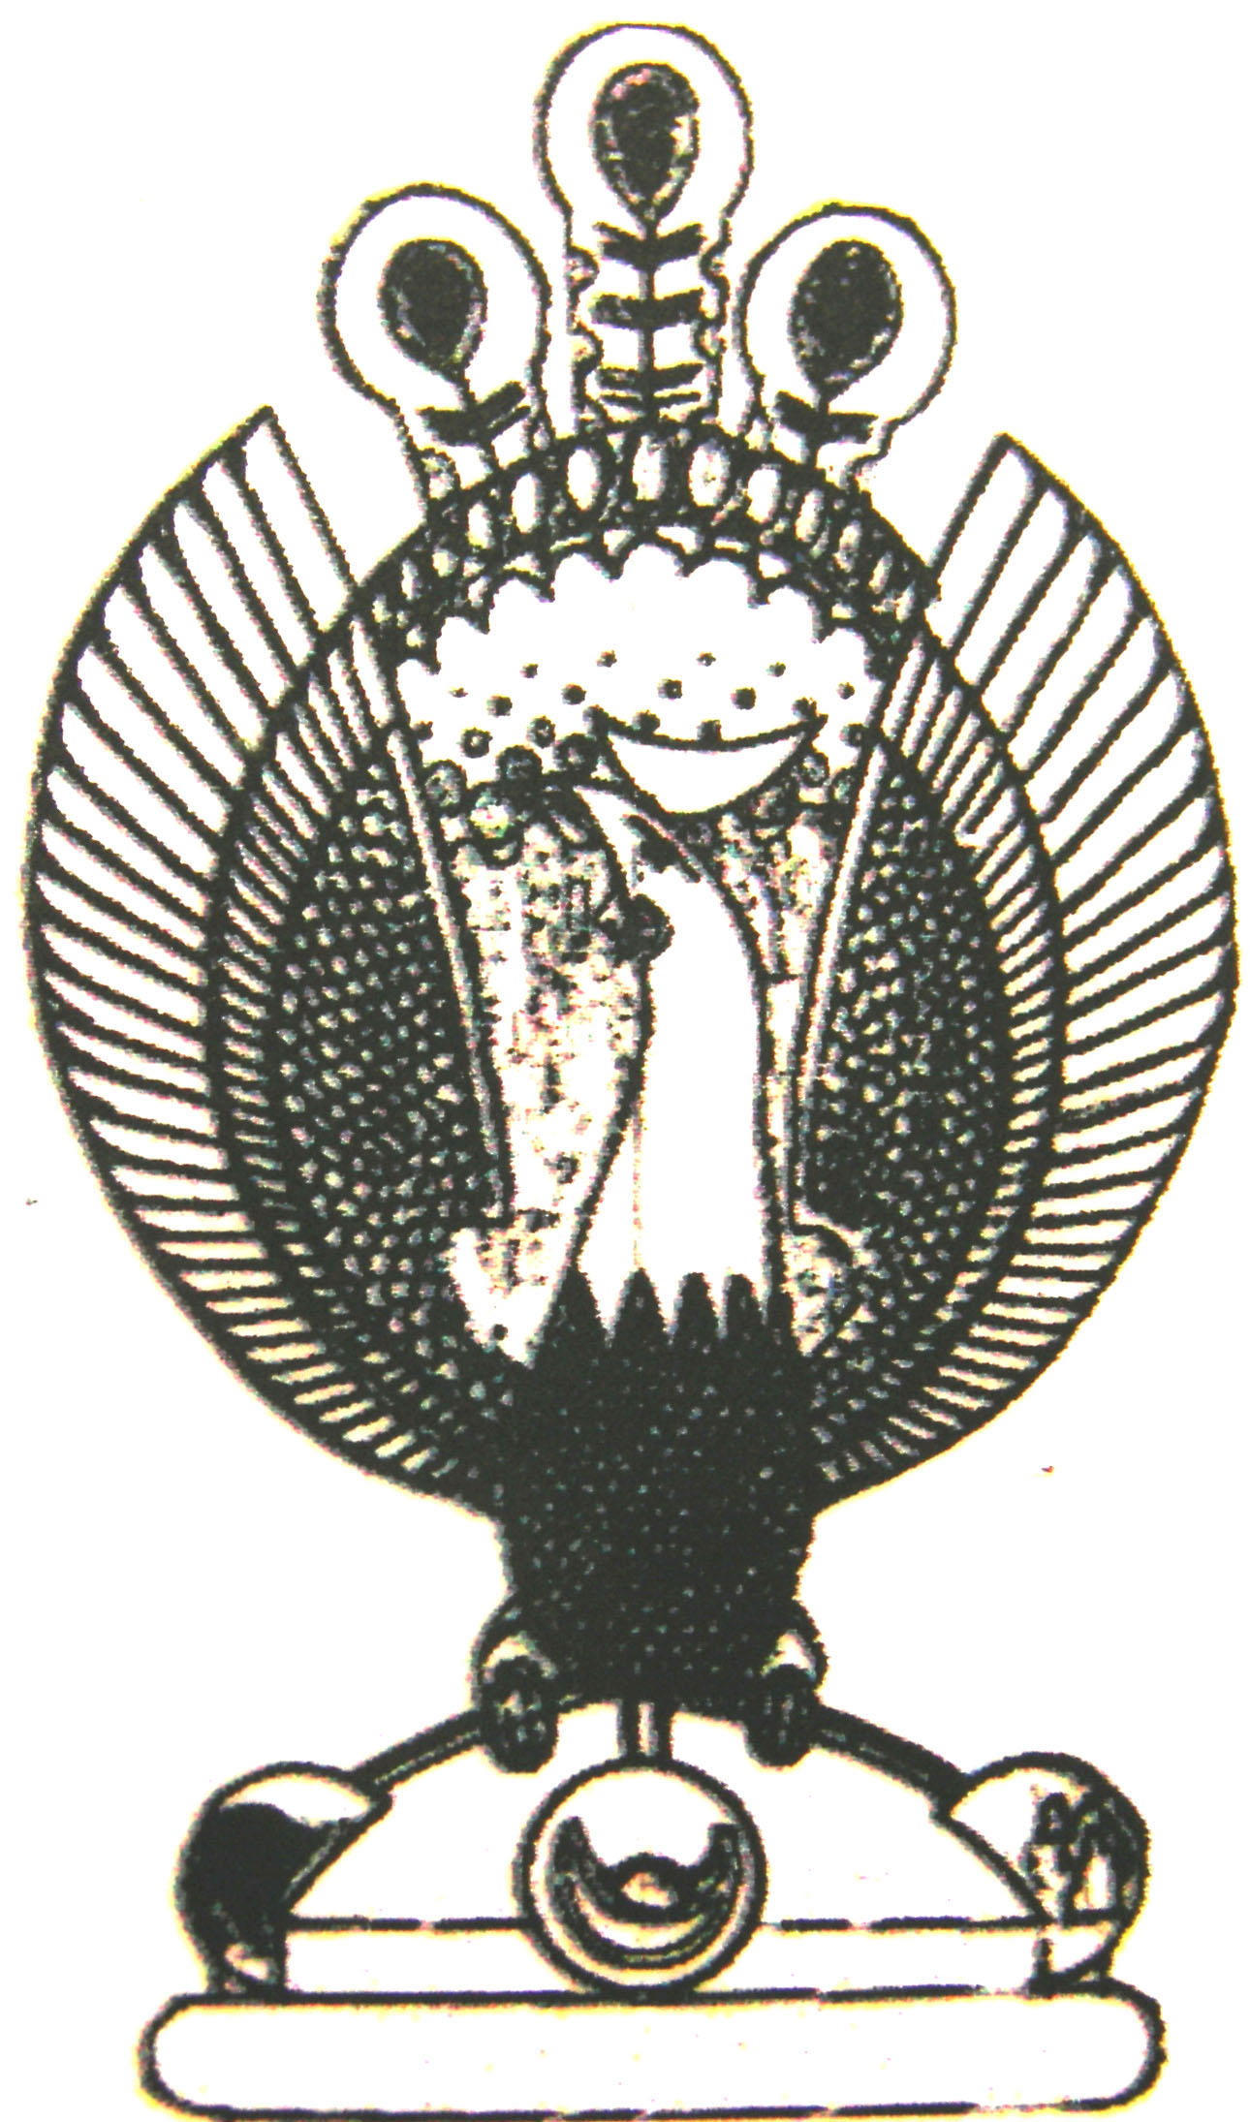

THE HERITAGE

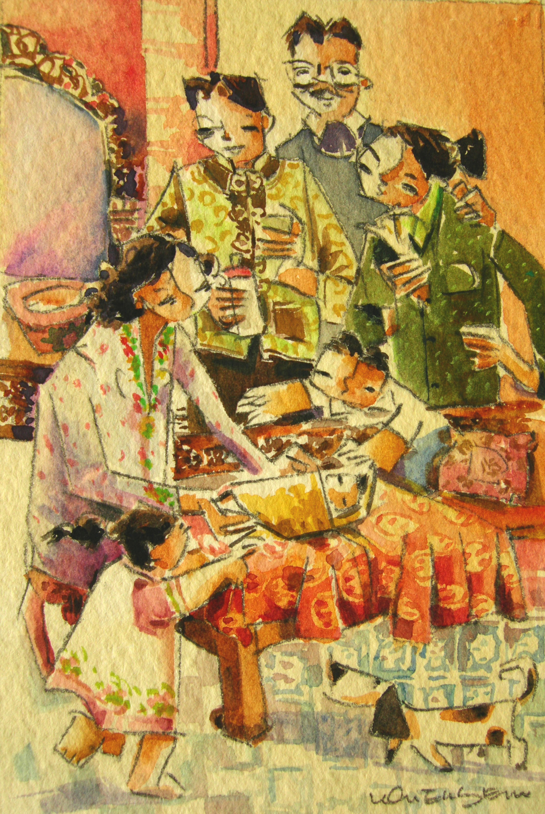
One Month Old
Month old babies would have their first haircut and be dressed in fine clothes and fine jewellery. They would be introduced to their ancestors for the first time, by way of worship at the family altar, with the assistance of their elders. Nasi kunyit with chicken curry is distributed, along with a sweet red dumpling filled with mashed green beans. Its form and shape depends on the gender of the baby. For a boy, the dumpling should be shaped into a turtle. It would be shaped into two peaches if the baby is a girl. After this, a popiah party and a cherki session will follow.

